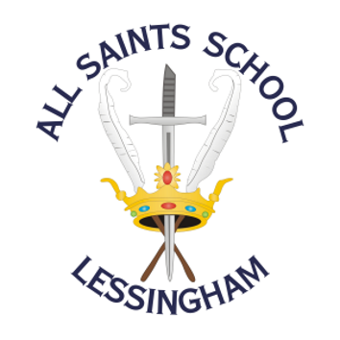 | ALL SAINTS SCHOOL  School Road, Lessingham, Norwich, Norfolk  NR12 0DJ  01692 582083  www.allsaintslessingham.co.uk  E-mail: office@allsaintslessingham.co.uk  Directors: Mrs J Gardiner and Mrs R Smith  Headteacher: Ms S Dangerfield
Friday 10th June 2022

Dear Parents,

We have arranged a sports day for years 7 to 11 at UEA on Friday 17th June 2022.

We will be leaving school soon after registration to arrive at UEA at 10.15am for a 10.30am start and will return to school mid-afternoon.

All students should attend school in full PE kit. The weather forecast is looking good towards the end of the week so please ensure your child has sun cream and a hat if required. They also need to bring a water bottle, lunch and snacks.

Photographs taken at the event will be shared via social media, please let us know by the end of school on Wednesday if you do not want your child included. We would not include student names with any photographs.

Parents and Carers are invited to come along to watch and support the students. If you would like to attend, there is also the option to take your child with you, however all students must then return to school afterwards in our minibus/car.

Please indicate below if you would like to join us and how many will be attending. Please also indicate if you will be transporting your child to the event.

Please return the form only if you are attending the event.

- ............... people will be attending sports day
- * I will / will not (*delete as necessary) be taking my child to the event

If you have any questions, please email the office.

Kind regards,
Sam Dangerfield

