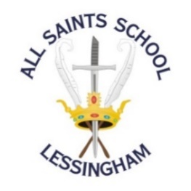
Uniform Order Request

Name of Student …………………………………....………… Year ………..……………
Sizes: 30” (7-8 yrs) 32” (9-10) 34” (11-12) 36” (XS) 38” (S) 40” (M) 42” (L) 44” (XL) 46” (XXL)
Item | Cost | Quantity | Size | Total |  | Office Use  To Order /  In stock | Office Use  Item received by Student | Office Use  Paid Y / N  Date
Maroon V-neck sweatshirt | £13.00
School tie | £7.50
Dark blue polo shirt  (required Easter until October half term) | £9.00
Maroon sports sweatshirt  (round neck) | £13.00
Sky blue sports polo shirt | £7.50
Blazer badge with school logo  (Senior school only) | £7.00
Dark navy jogging bottoms  Age 7-8 (26”), 9-11 (28”), 12-13 (29”):  Age 14-15 and Adult S, M, L, XL: | £5.50  £9.00
Total cost of order

Following our recent consultation, the shirt, tie and blazer will be voluntary.

This means that if your child would prefer to wear the t-shirt and jumper all year round this is absolutely fine, but if your child likes the shirt, tie and blazer that is ok as well.

I enclose cash/cheque made payable to ‘All Saints School Ltd’ as payment for the uniform ordered

Payment must be included with your order For payment via BACS, please contact the office.

Signed ………………………............…………………..Parent/Guardian Date ………………………..

