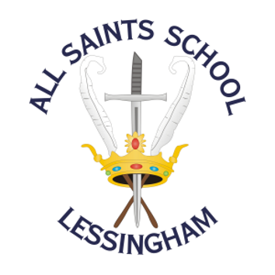 | ALL SAINTS SCHOOL  School Road, Lessingham, Norwich, Norfolk  NR12 0DJ  01692 582083  www.allsaintslessingham.co.uk  E-mail: office@allsaintslessingham.co.uk  ACHIEVEMENT FOR ALL  Directors: Mrs J Gardiner and Mrs R Smith  Headteacher: Ms S Dangerfield
Friday 13th October 2023

KS4 Parent’s Evening – Wednesday 1st November 2023

Dear Parents and Carers

On Wednesday 1st November between 3.30pm and 5.30pm, we will be holding KS4 parents evening. This includes years 10 and 11.
If you are able to come into school, please can you indicate what time would suit you best: 3.30pm-4.30pm or 4.30pm-5.30pm.
If you are unable to come into school on Wednesday 1st November but would like a phone call with your son or daughter’s teacher, please indicate below.

Please return the reply slip by 10am on Tuesday 17th October so we can confirm timings with you before half term.

Kind regards,
Sam Dangerfield

KS4 Parent’s Evening – Wednesday 1st November 2023

I would like to come into school: 3.30-4.30pm 4.30-5.30pm

I am unable to come into school but would like a phone call

I am unable to come into school and do not want a phone call

Name of student: _______________________________________________________

Parent / Carer Name: _______________________________________________________

Best contact number: _______________________________________________________

