Six Weeks of Fine Motor activities to improve the intrinsic hand skills required for handwriting
MON: PINCER GRIP
1 | Placing buttons along a line to form first letter of name | 2 | Threading cheerios/pasta tubes/straw segments onto dried spaghetti
3 | Making elastic band shapes on geo-board | 4 | Peg board pictures
5 | Inset puzzles (with a twist) | 6 | Peg cards (corresponding letters or numbers)
TUES: WRIST EXTENSION
1 | Driving cars/trains over bridges, around bends etc | 2 | Sticky back plastic collage on wall or window
3 | Make a sticker scene on wall | 4 | Animal tape rescue
5 | Making handprint animals (with paint or drawing around hand) | 6 | Drawing on paper taped under the desk
WED: OPEN THUMB WEB SPACE
1 | Wind-up toy race | 2 | Making caterpillar pets with pipe cleaners and beads (could use corresponding colours or copy sequence)
3 | Tennis Ball Monsters | 4 | Using eye dropper to drop coloured water onto blotting paper or fill lids
5 | Threading necklace with coloured pasta | 6 | Pushing spaghetti spines or sticks into playdough hedgehog and pulling out
THURS: TRANSLATION
1 | Posting pipe cleaners into colander (to make hairy monster!) | 2 | Posting coins or buttons into container
3 | Lacing card | 4 | Nuts and Bolts through basket
5 | Push straw worms into their holes | 6 | Pom pom posting and sorting
FRI: SEPARATION OF SIDES OF HAND
1 | Using tongs to sort animals into colours | 2 | Using tweezers to pick insects out of a basket web
3 | Oven glove / other puppets | 4 | Use tweezers to sort pom poms into colours on a muffin tray or egg box
5 | Feed the Frog / dino with tweezers or tongs | 6 | Use tongs to find objects in sand tray
Six Weeks of Fine Motor activities to improve the intrinsic hand skills required for handwriting
Definitions and Explanation
Pincer Grip
A pincer grip, or pincer grasp, refers to the action of closing the thumb and index finger together in order to hold an object. A pincer grip is a sign of fine motor control. Babies typically develop this skill between the ages of nine and 12 months, although all children develop at different rates.
The ability to use a neat pincer grasp supports the development of a functional grasp when using tools and when holding a pencil.
Wrist Extension
Wrist extension refers to the position of the wrist whereby there is a straight line between the forearm and the hand (similar to holding a tray of food).
If the wrist is flexed when writing (with the thumb positioned towards the body), this limits the dynamic movement of the wrist and fingers which are essential when forming letters correctly and writing fluidly.
Open Thumb Web Space
The web space is the area between the thumb and index finger. An open web space (with thumb and fingers in an ‘ok’ sign) gives increased mobility and control of fingers and contributes to an effective pencil grasp when writing.
Translation
Translation is an example of an ‘in-hand manipulation’ skill. Translation allows you to move objects from the palm of the hand to the fingertips and vice versa using only one hand. An example of translation is moving coins from your palm to your fingertips to put the coins in a piggy bank. This skill is required to be able to pick up a pencil and move it into the correct position for writing or to adjust your fingers on the pencil or writing tool when writing.
Separation of the Sides of the Hand
Your hand may be split into two sides. The thumb, index and middle fingers make up the ‘skill’ side of the hand and are responsible for gripping and movement of your pen or pencil when writing. The ring and little fingers make up the ‘power’ side of the hand and provide support and stability to the whole hand while the “skill side” moves freely to manipulate objects. Motoric separation of the sides of the hand is an important skill for manipulation and use of tools such as pencils, cutlery, scissors, etc.
The following activities aim to promote the development of each of the above intrinsic hand skills. They are designed to be completed daily over a period of 6 weeks using a range of readily available and everyday resources.
Buttons
You will need: | - Selection of colourful buttons  - Card with patterns, the child’s name or letters of the child’s name drawn out
What to do:  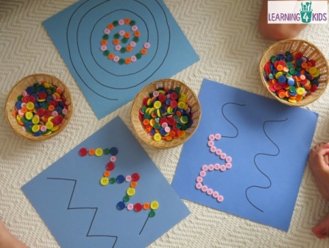 | Encourage the child to line up the buttons along the lines of the letters or along the patterns  Encourage them to try picking up more than one button at a time and holding a selection in their hand  Encourage the child to steady the paper with their other hand or pass buttons from one hand to the other  Position the bowl of buttons to the side opposite the child’s preferred hand to encourage crossing midline
This helps: | Pincer grip  In hand manipulation (if picking up more than one)  Bilateral coordination  Crossing midline

Geoboard
You will need: | - Selection of elastic bands  - Geoboard or spiky ball
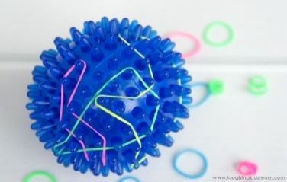  What to do:  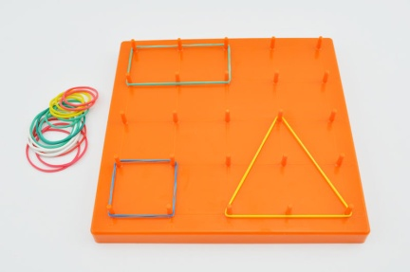 | Encourage the child to stretch out the elastic bands over the board or spikes on the ball to create different patterns  Encourage them to try picking up more than one elastic band at a time and holding a selection in their hand  Encourage the child to use both hands to stretch out the elastic band  Encourage the child to make different shapes and patterns – provide a design to copy  Try plucking the bands and listening to the sound it makes  Position the bands to the side opposite the child’s preferred hand to encourage crossing midline
This helps: | Pincer grip  Finger strength  In hand manipulation  Bilateral coordination  Crossing midline

Spaghetti Threading
You will need: | - Sticks of spaghetti or straws  - Selection of Cheerios / Pasta tubes / Beads  - Plasticine or playdough to poke the straws or spaghetti into
What to do:  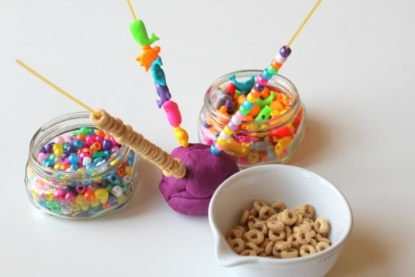 | Poke some long strands of spaghetti or straws upright into the plasticine  Encourage the child to thread the pasta shapes or cheerios onto the spaghetti  Encourage the child to hold more than one cheerio or pasta shape at a time  Position the pasta shapes or cheerios to the side opposite the child’s preferred hand to encourage crossing midline  Use straws and larger beads / items for children who find manipulating the smaller items difficult  Use silly straws for more of a challenge
This helps: | Pincer grip  In hand manipulation (if picking up more than one)  Crossing midline

Peg Board Pictures
You will need: | - Peg Boards  - Pegs  - Designs to copy
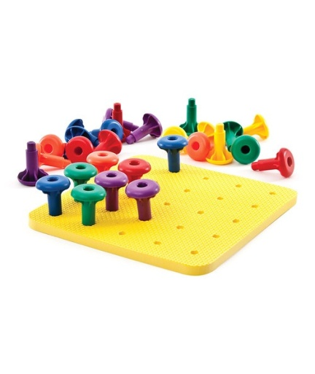  What to do: | Encourage the child to pick up and place the pegs using the tips of their thumb and index finger  Encourage the child to make their own pattern or copy a design  Encourage the child to hold more than one peg at a time  Position the pegs to the side opposite the child’s preferred hand to encourage crossing midline  Use larger peg / boards for children who find manipulating the smaller items difficult
This helps: | Pincer grip  In hand manipulation (if picking up more than one)  Bilateral coordination  Crossing midline

Peg Cards
You will need: | - Counting / colour or alphabet cards  - Clothes Pegs
What to do:  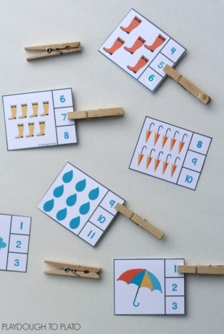 | Encourage the child to open the pegs using their thumb and index finger  Support the child to select the correct answer on the card and clip the peg onto it  Encourage the child to hold the card with their opposite hand  Position the pegs to the side opposite the child’s preferred hand to encourage crossing midline
This helps: | Pincer grip  Finger strength  Bilateral coordination  Crossing midline

Inset Puzzles (with a twist)
You will need: | - Various inset puzzles with knobs on the pieces  - For an added twist, put the pieces of the puzzles in various containers e.g. twist open tupperware, clip lock boxes, zipped / buttoned bags
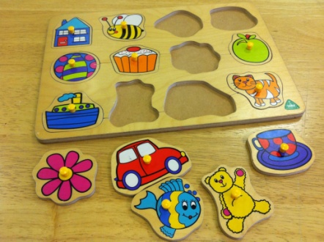  What to do: | Encourage the child to use the tips of their thumb and forefinger to take out and replace the puzzle pieces.  Use puzzles with different sized knobs and different shapes and images to make it more difficult  For an added twist, put the puzzle pieces in a variety of containers and encourage the child to open them to find the ones that match.
This helps: | Pincer grip  Finger strength  Bilateral coordination  Crossing midline  Self care skills (if using zippered or buttons bags)

Driving Cars
You will need: | - Selection of cars  - Bridges / track or cardboard or masking tape ‘road’
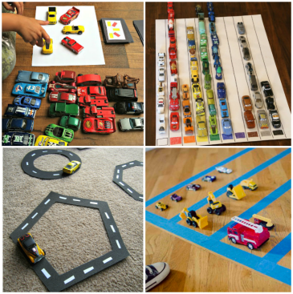  What to do: | Encourage the child to drive the car up and over bridges / round the tracks / bends  Add an educational element by numbering or labelling the cars and ‘parking’ them along the child’s name / number line
This helps: | Wrist extension  Bilateral coordination  Crossing midline

Sticky Wall
You will need: | - Sticky-backed plastic  - Tape  - Pieces of paper / tissue paper / leaves / flowers / feathers or other items
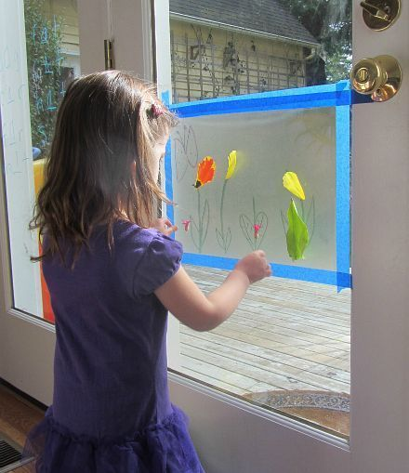  What to do: | Stick the sticky backed plastic up on the wall or window with the sticky side facing outwards  Encourage the child to create a collage by sticking items to the plastic  Perhaps create a ‘stained glass’ window effect using pieces of tissue paper  Draw an image on the back of the plastic for the children to ‘fill in’ or keep it open  Try themed collage e.g. seasonal, nature, space, animals
This helps: | Wrist extension  Pincer grip  Bilateral coordination  Crossing midline

Sticker Scene
You will need: | - Paper  - Stickers  - Tape
What to do:  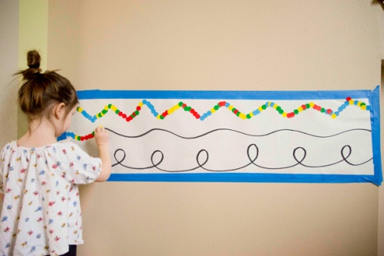 | Tape up some paper on the wall or board or floor  Provide a variety of stickers for the children to peel off and use to create their own scene or pattern e.g. dots along their name  Add an educational element and use coloured dots / shapes and sort onto coloured paper
This helps: | Wrist extension  Pincer grip  Finger strength  Bilateral coordination  Crossing midline

Drawing under the desk
You will need: | - Paper  - Tape  - Crayons / coloured pens or pencils
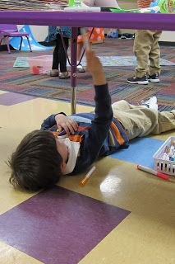  What to do: | Tape some pieces of paper to the underside of the desk  Have the students lie on their backs and draw on their paper  Pretend to be ‘mechanics’
This helps: | Wrist extension  Crossing midline

Handprint animals
You will need: | - Paper  - Tape  - Paint or pens / pencils
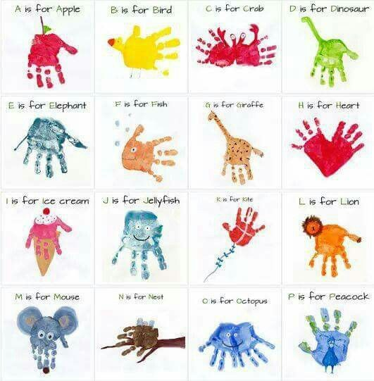  What to do: | Tape up some paper on the wall  Have the student create handprints using paint or draw around their hand  Add eyes and legs to their hands to create different animals e.g. octopus / jellyfish / fish – see https://www.pinterest.co.uk/explore/hand-print-animals/  Or draw an animal outline and have them ‘fill it in’ with handprints e.g. fish scales / hedgehog spines
This helps: | Wrist extension  Bilateral coordination  Crossing midline

Animal Tape Rescue
You will need: | - Selection of plastic animals  - Masking or painters tape
What to do: | Use short pieces of tape to stick the animals to a whiteboard or wall  Have the students peel off the tape and rescue the animals  Position some high and some low down to encourage greater extension
This helps: | Wrist extension  Bilateral coordination  Crossing midline

Wind-up Toys
You will need: | - A selection of wind-up toys  - Masking tape, string or shoelaces
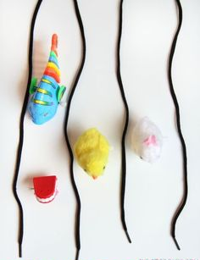  What to do: | Encourage the students to wind up the toys and see how they move  Use masking tape, string or shoelaces to create a track across the table or start and finish lines and race the toys
This helps: | Stabilisation of thumb webspace  Bilateral coordination  Pincer grip  Wrist extension  Precision rotation

Caterpillar Pets
You will need: | - Pipe cleaners  - Beads
What to do:  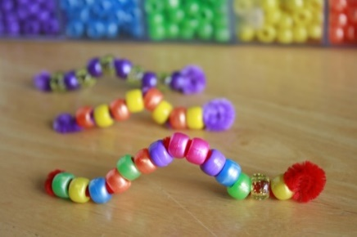 | Curl the end of a pipe cleaner around to make a head  Thread beads onto the pipe cleaner and curl over the end to keep them in place  Have fun bending and playing with your caterpillar
This helps: | Stabilisation of thumb webspace  Bilateral coordination  Pincer grip  Wrist extension  Translation

Tennis Ball Monsters
You will need: | - Tennis ball monster  - Small objects e.g. marbles, beads, small figures, coins
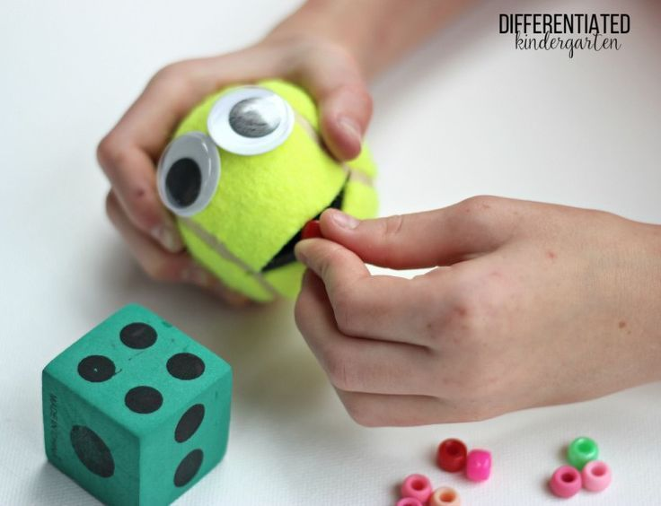  What to do: | Show the child how to squeeze the tennis ball at the sides to open the mouth  Encourage the child to ‘feed’ the monster by posting small items into its mouth and taking them out again
This helps: | Stabilisation of thumb webspace  Bilateral coordination  Pincer grip  Wrist extension  Hand strength  Translation

Eye dropper activities
You will need: | Eye dropper  Water coloured with food colouring  Blotting paper  Or various sized lids and water
What to do:  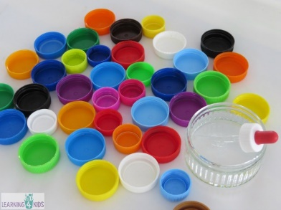 | Encourage the student to use the eye dropper to drop coloured water onto blotting paper to make patterns / pictures  Encourage the student to use the eye dropper to fill up a variety of different sized lids
This helps: | Stabilisation of thumb webspace  Wrist extension  Bilateral coordination  Pincer grip  Crossing midline  Finger strength

Pasta Threading
You will need: | - Coloured pasta shapes  - String or wool or a shoelace
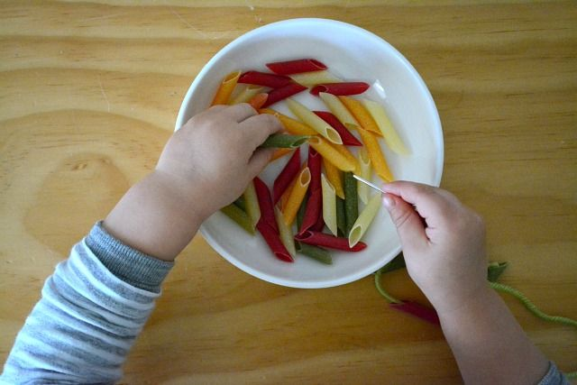  What to do: | Encourage the student to create their own necklace by threading pasta shapes onto a string or lace  Ensure the end of the string is taped or stiffened in order to enable the student to be more successful at the activity
This helps: | Stabilisation of thumb webspace  Bilateral coordination  Pincer grip  Wrist extension  Translation

Stick Hedgehogs
You will need: | - Playdough or plasticine  - Sticks and twigs or dried spaghetti
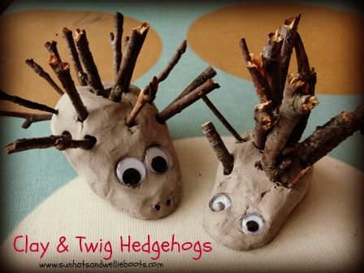  What to do: | Make a hedgehog shape out of playdough or plasticine  Encourage the student to push in sticks of different lengths to make its spines  Encourage the student to pull them out again and tidy up after the activity  Support the student to go outside to find and break up the sticks for the activity
This helps: | Stabilisation of thumb webspace  Wrist extension  Bilateral coordination  Pincer grip  Crossing midline  Finger strength

Colander Monsters
You will need: | - Colander  - Pipe cleaners
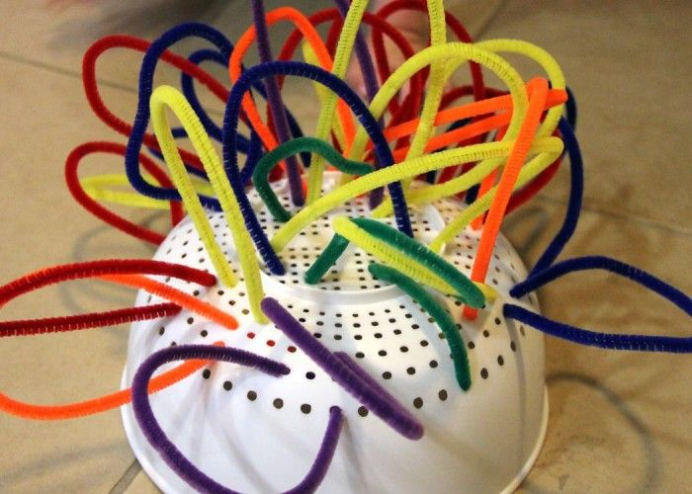  What to do: | Encourage the child to push pipe cleaners into the holes of the colander  Encourage the child to bend the pipe cleaners over to push in both ends  Bend and curl the pipe cleaners to create a  hairy monster or silly hairdo  Turn the colander over and try making a ‘net’ or ‘spider web’ inside
This helps: | Translation  Wrist extension  Bilateral coordination  Pincer grip  Crossing midline

Posting buttons or coins
You will need: | - Coins or buttons  - Container with slots cut into it or piggy bank
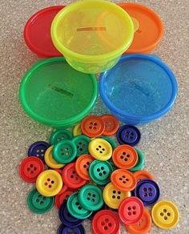  What to do: | Encourage the child to post the coins or buttons into the slot of the container  Encourage the child to see how many they can hold in their hand whilst posting them one by one  Encourage the child to stabilise the container with one hand whilst posting the items with the other  Situate the container opposite the child’s preferred hand to promote crossing midline  Add an educational element by asking the student to post a number of coins as indicated on a card or on the container or colour match to the container
This helps: | Translation  Wrist extension  Bilateral coordination  Pincer grip  In-hand manipulation (if holding more than one)  Crossing midline

Lacing Cards and Toys
You will need: | - Lacing cards or toys
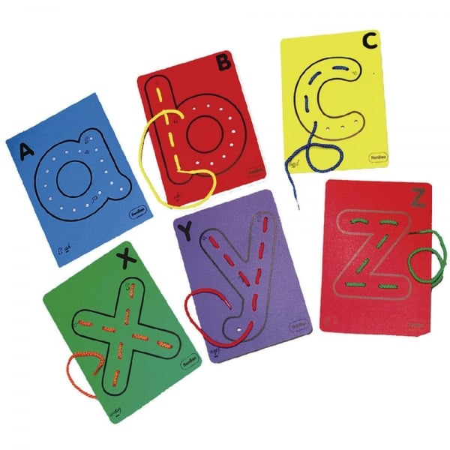  What to do: | Encourage the child to thread the lace in and out of the card or over the sides of the card  Support the child to pull the lace all the way through to encourage wrist extension  Create your own lacing cards by punching holes in a laminated picture or letter
This helps: | Translation  Wrist extension  Bilateral coordination  Pincer grip  Crossing midline

Straw Worms
You will need: | - Straw ‘worms’  - Egg box home
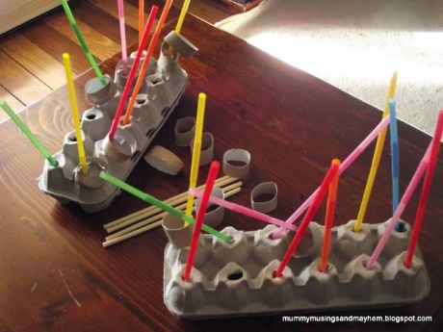  What to do: | Encourage the child to push the straws into the holes in the egg box home.  See how many they can push through and pull out the other side.  Gradually cut and reduce the size of the straws to make the task more challenging.
This helps: | Translation  Wrist extension  Bilateral coordination  Pincer grip  In-hand manipulation (if holding more than one)  Crossing midline

Nuts and Bolts
You will need: | - Metal or plastic nuts and bolts or construction set  - Basket or tin with holes
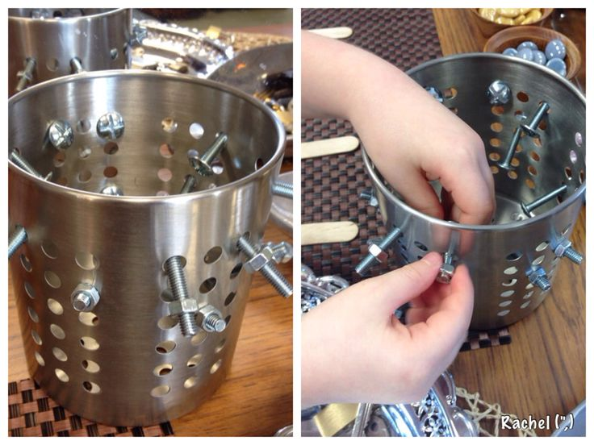  What to do: | Push a variety of nuts and bolts through the holes in a basket and provide other loose parts  Encourage the student to undo the nuts and bolts attached to the basket and attach other pieces themselves
This helps: | Translation  Wrist extension  Bilateral coordination  Pincer grip  Crossing midline  Finger strength  Precision rotation

Posting Pom Poms
You will need: | - Selection of pom poms  - Plastic bottles
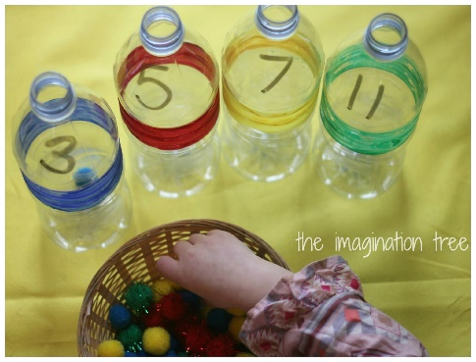  What to do: | Encourage the student to post the pom poms into the water bottles one at a time  Encourage the child to see how many pom poms they can hold in one hand at a time  Encourage the child to hold the bottle in one hand whilst posting the pom poms with the other  Add an educational element and see if they can match the colour of the pom poms to a coloured bottle or post the correct number of pom poms as marked on the bottle
This helps: | Translation  Wrist extension  Bilateral coordination  Pincer grip  In-hand manipulation  Crossing midline

Animal sorting with tongs
You will need: | - Tongs  - Coloured counting animals or objects  - Coloured or numbered containers
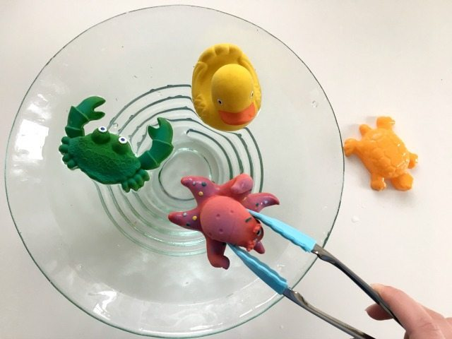  What to do: | Encourage the child to use the tongs to pick up the animals and sort them into the coloured or numbered containers  Encourage the child to pick up one toy at a time
This helps: | Separation of the sides of the hand  Bilateral coordination  Pincer grip  Crossing midline

Pom Pom sorting with tweezers
You will need: | - Tweezers  - Pom Poms  - Muffin Tray or egg box with coloured or numbered inserts
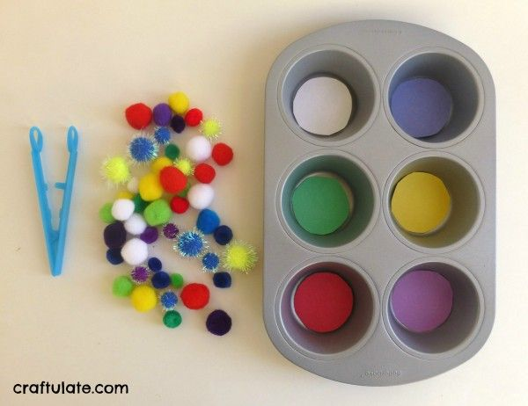  What to do: | Encourage the student to pick up the pom poms using the tweezers and sort them into colours or count out numbers into the tray  Encourage the student to stabilise the tray with their opposite hand  Position the pom poms to the side opposite their dominant hand to encourage crossing midline
This helps: | Separation of the sides of the hand  Bilateral coordination  Pincer grip  Crossing midline

Puppets
You will need: | - Oven glove with stickers / stick on features  - Or glove puppets with mouths  - Play food
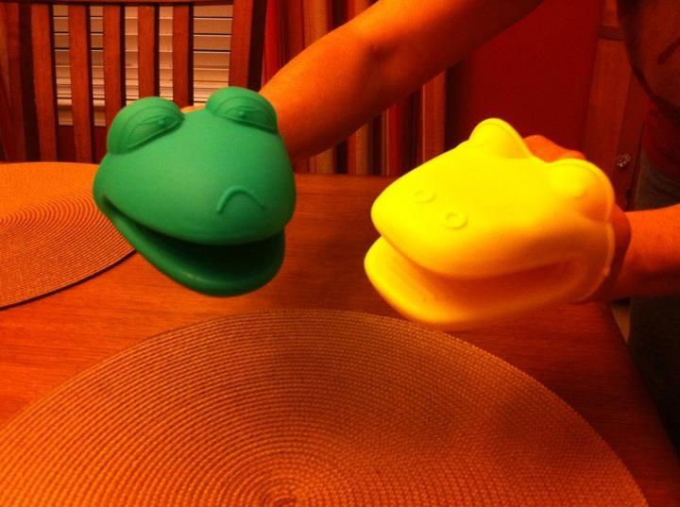  What to do: | Support the child to create their own oven glove puppet or use a regular puppet  Encourage the student to open and close the puppet’s mouth and ‘feed’ it play food items  Use sound effects / funny voices to bring their character to life  Have the student put on a mini show for their classmates
This helps: | Separation of the sides of the hand  Wrist extension  Bilateral coordination  Crossing midline

Spider Web
You will need: | - Plastic spiders or bugs  - Basket with holes threaded with string to make a ‘web’  - Tweezers or clothes peg
What to do:  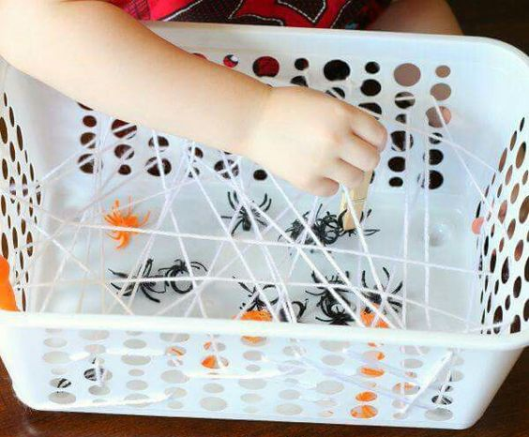 | Encourage the child to use the tweezers or peg to pull out the spiders from the web  Ensure the student positions their fingers correctly on the tweezers  Add an educational element to match the number of spiders to a pre-printed card
This helps: | Separation of the sides of the hand  Bilateral coordination  Pincer grip  Crossing midline

Feed the frog
You will need: | - Tweezers or tongs  - Frog or box with a ‘mouth’ to feed  - ‘Food’ for the frog – plastic flies / pom poms / images of flies
What to do:  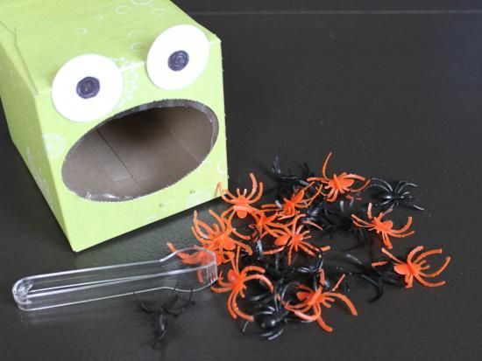 | Encourage the child to use the tongs or tweezers to pick up the food to post in the frog’s mouth  Add an educational element by asking the child to feed the frog a certain number of flies / pieces of food
This helps: | Separation of the sides of the hand  Bilateral coordination  Pincer grip  Crossing midline

Buried Animals
You will need: | - A tray of sand or rice  - Animals or character toys  - Tongs or tweezers
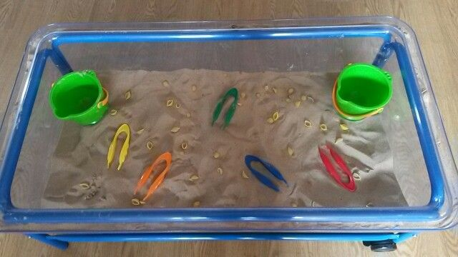  What to do: | Bury a selection of toys in the sensory tray  Encourage the student to use the tongs or tweezers to find and pull out the buried objects  Add an educational element by encouraging the child to find a set number of items or match them to picture or number cards
This helps: | Separation of the sides of the hand  Bilateral coordination  Pincer grip  Crossing midline

