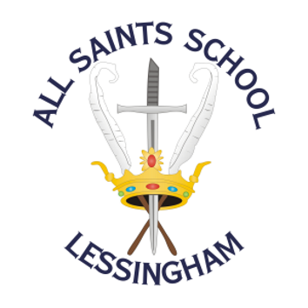 | ALL SAINTS SCHOOL  School Road, Lessingham, Norwich, Norfolk  NR12 0DJ  01692 582083  www.allsaintslessingham.co.uk  E-mail: office@allsaintslessingham.co.uk  ACHIEVEMENT FOR ALL  Directors: Mrs R Smith and Mrs J Gardiner  Headteacher: Ms S Dangerfield
Thursday 25th September 2025

Dear Parents and Carers
KS4 Parent’s Evening
Thursday 16th October 2025

On Thursday 16th October between 3.30pm and 6pm, we will be holding KS4 parents evening. This includes years 10 and 11.
If you are able to come into school, please can you indicate what time would suit you best: 3.30pm-4.30pm or 4.30pm-6pm.
If you are unable to come into school on this date but would like a phone call with your son or daughter’s teachers, please indicate below. We will do our very best to keep appointments on time, but please bear with us if they over-run a bit.

Please return the reply slip by Monday 6th October so we can confirm timings with you.

Kind regards,
Sam Dangerfield

KS4 Parent’s Evening
Thursday 16th October 2025

I would like to come into school: 3.30-4.30pm 4.30-5.30pm
I am unable to come into school but would like a phone call

Please tick or highlight which subject teachers you would like to talk to:

 | Art |  | Drama |  | Music |  | Form Tutor
 | Asdan |  | English |  | PE |  | Post 16/Exams
 | Child Development |  | History |  | Philosophy & Ethics
 | Computer Science |  | Maths |  | Science

Name of student: _______________________________________________________

Parent / Carer Name: _______________________________________________________

Best contact number: _______________________________________________________

